**LESSON 3**

**HTML**

**New HTML attribute, “class “**

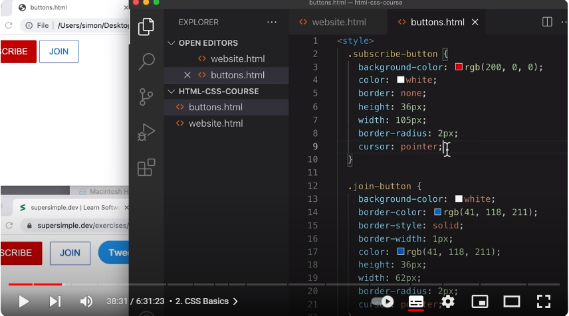

Margin-Right: to create the space between the 2 buttons

GENERAL TECHNIQUE  
Create Element with HTML

Style it one by One by the use of CSS

Tweet button

Border-radius: For us to achieve a round border, we set the radius half of the smallest between height and width

Exercise 2

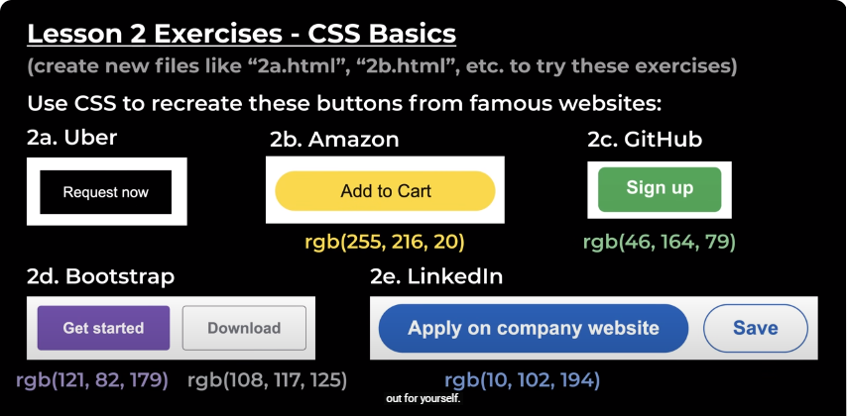

Chapter 3

Hover, Transition and Shadows

When we hover, we basically add other style on the previous style.

.subscribe-button:hover{

opacity: 0.8; transparency of an element

}

Another pseudo-class

.subscribe-button:active{

Opacity: o.5;

Opacity- tells us how we see through, and the normal value is 1, used to fade out an element

}

.join-button:hover{

Background-color:

Color:

}

.join-button:active{

Opacity: 0.8}

**Transition** in our main subscribe button style

Transition: opacity 1s;

When you want to transition multiple style we just use the comma

**Shadow**

**Tweet**

Box-shadow:

1st value, right

2nd value bottom

3rd value is blur

Last value color

Rgba a- opacity

As we decrease the value it is getting more transparent.

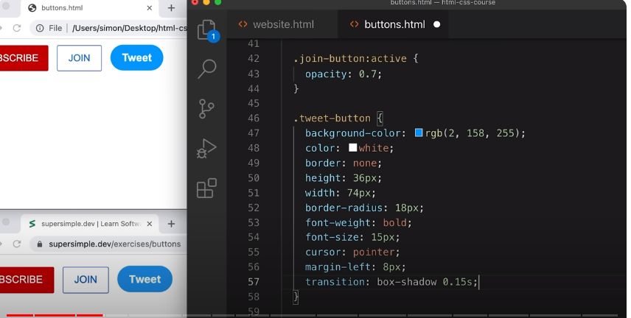

**Lesson 4**

**Chrome DevTools & CSS Box Model**

Easy to demonstrate than explain,

Convert from hex to rgb (calculator

**CSS Box Model**

Margin, top, right, bottom and left

Padding-left

We delete both height and width and padding

Vertical align: top

Next, we shall do **text.**

**Lesson 5**

**Text Style**

**text.html**

**Style**

**Video_title**

**Font-family: Aerial;**

**Font-size: 18px;**

**Width: 300px;**

**Font-weight: bold;**

**Line_height: 24px;**

**.video stats**

**<p class= “Video_title”> </p>**

**We create the style element**

**General Technique:**

1. **Create element with HTML**
2. **Style with CSS one-by-one.**

**To break the line text, we shall have the width**

**Line-height: spacing between lines**

**Html entity code middle dot- for styling special characters like check-mark**

**By default, the paragraph comes with margin**

**To avoid repetion of a certain style, we create p at the top of the style**

**P{ font-family: Arial;**

**Span element, it allows us**

**We create a class at (span_link).**

